**ABC Gaming – Loyalty Points Case Study**

**Submitted by: K. Ravi Kumar**

**Email**: kosgir143@gmail.com | **Phone**: 7702625476

<https://github.com/ravikumar-143/Vindiata-Consulting-Assignment/blob/main/ABC_Loyalty_Analysis_K_Ravi_Kumar.pbix>

download the RAW code from Github and open in Power BI Desktop.

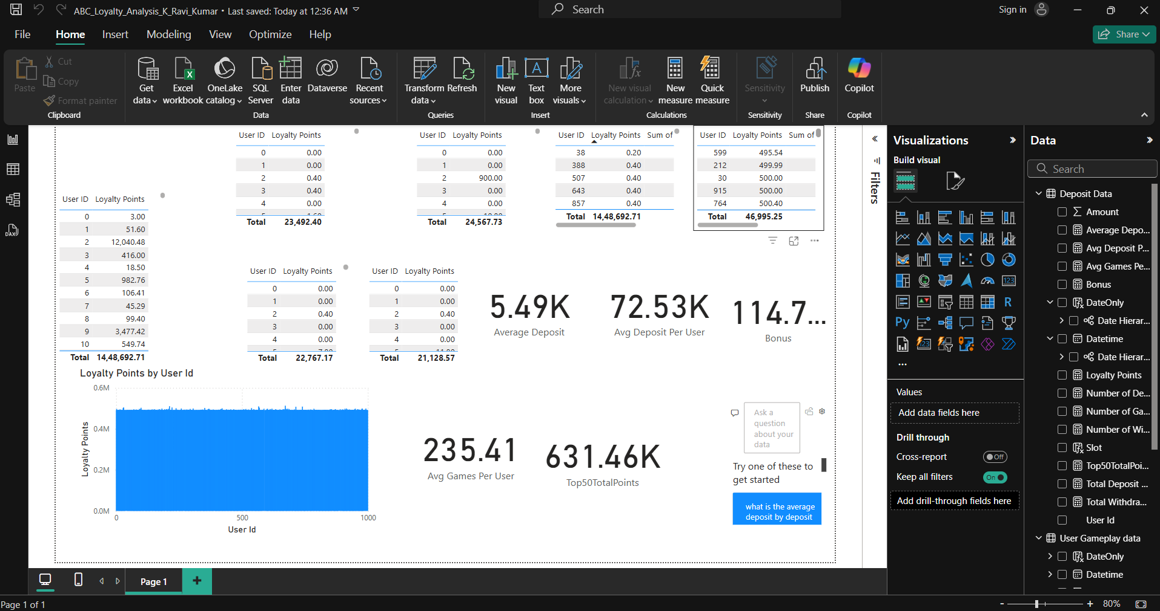

**Why We Create a Separate Users Table (No Duplicates)**

In this assignment, we can't remove duplicates from the **Deposit**, **Withdrawal**, or **Gameplay** tables because:

* Each row represents a **unique event** (e.g., a deposit or a game session)
* You need those rows to **accurately count**:
  + Total deposits
  + Number of withdrawals
  + Number of games played

**Problem:**

If you try to create a relationship directly from these tables:

* Power BI sees **duplicate User IDs** in each table
* It may only allow a **Many-to-Many** relationship (not ideal)
* You **can’t use Single Direction filtering reliably**

**Smart Solution: Create a Users Table**

**What you did:**

* Created a new table with:

Users = DISTINCT(UNION(SELECTCOLUMNS('Deposit Data', "User ID", [User ID]),

SELECTCOLUMNS('Withdrawal Data', "User ID", [User ID]),

SELECTCOLUMNS('User Gameplay Data', "User ID", [User ID])))

* This ensures **one unique row per user**

**Relationships (Model View):**

| **From Table** | **To Table** | **Type** | **Direction** |
| --- | --- | --- | --- |
| Users[User ID] | Deposit Data[User ID] | One-to-Many | Single |
| Users[User ID] | Withdrawal Data[User ID] | One-to-Many | Single |
| Users[User ID] | User Gameplay[User ID] | One-to-Many | Single |

**Part A – Loyalty Points Calculation**

ABC Gaming rewards its users with loyalty points based on deposit, withdrawal, and gameplay activities. The formula was used across various date-time slots as instructed.

**Slot-wise Player Loyalty Points (4 Slots):**

Created filtered tables in Power BI for:

* **2nd October – S1 (12 AM to 12 PM)**
* **16th October – S2 (12 PM to 12 AM)**
* **18th October – S1**
* **26th October – S2**

Each table visual displays **User ID** and their respective **Loyalty Points** for that slot.

**Overall Ranking for October:**

* Loyalty points were calculated using the provided formula:

Loyalty = 0.01 * Deposit

+ 0.005 * Withdrawal

+ 0.001 * max((#Deposits - #Withdrawals), 0)

+ 0.2 * Number of Games Played

* A RANKX() DAX measure was used to rank players based on total loyalty points.
* In case of tie, number of games played was used as the second sort criteria.

**Aggregate Metrics:**

* **Average deposit amount** – calculated using a DAX measure on Deposit Amount
* **Average deposit per user** – total deposit divided by distinct users
* **Average games per user** – calculated using DISTINCTCOUNT(User ID) logic

**Part B – Bonus Allocation Strategy**

**Goal:**

Distribute ₹50,000 fairly among the top 50 players based on performance.

**✅ Logic Used:**

* Used the total loyalty points of top 50 players (via DAX filter on Rank ≤ 50).
* Bonus amount for each user calculated proportionally:

Bonus = (User Loyalty / Total Top 50 Loyalty) * 50000

* Final visual includes User ID, Loyalty Points, Rank, and Bonus Amount

This ensures that players who contributed more via deposits and gameplay receive a higher share — a fair and performance-linked distribution.

**Part C – Is the Loyalty Formula Fair?**

The loyalty point formula is **simple and effective** for capturing platform activity. However, there are a few areas for improvement:

**What works:**

* Rewards both financial transactions and gameplay
* Encourages users to stay active on the platform

**What could be improved:**

* **Withdrawals** are rewarded, which might reduce fund retention
* **Games Played** carries heavy weight (0.2) which may be exploited
* No reward for **winning**, **referrals**, or **loyalty streaks**

**Suggestions:**

* Reduce the weight of games played to 0.1
* Remove or minimize points for withdrawals
* Add new metrics like login streaks, referral success, and win ratio
* Consider recency-based points to encourage consistent activity

Final Opinion

The formula is a good starting point, but not entirely fair. To make it robust and business-aligned, it should reward retention, gameplay quality, and loyalty behavior — not just quantity of actions.